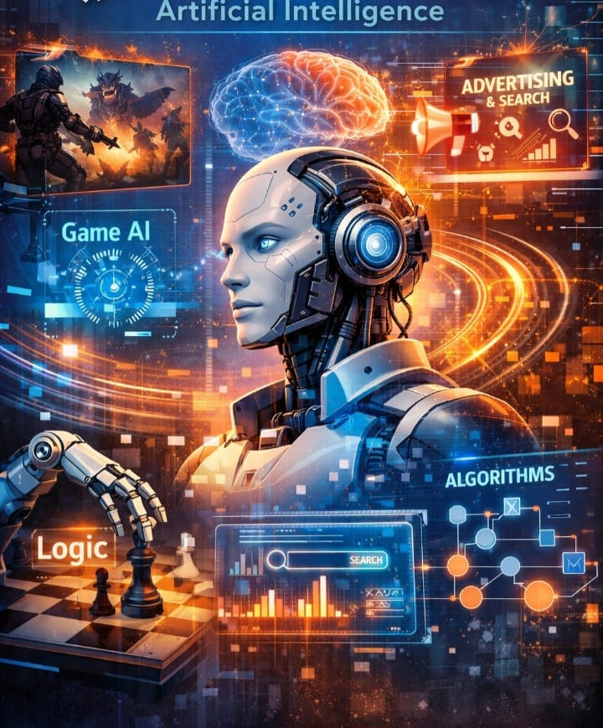

①Artificial Intelligence
②Machine Learning

By Jawad Jammoul

